Second Wind Community Band planning to celebrate

first 25 years with original music
Elizabeth Patterson (elizabeth.patterson@cbpost.com)
Published: Jun 01 at 8:54 p.m.
Updated: Jun 04 at 7:14 a.m.
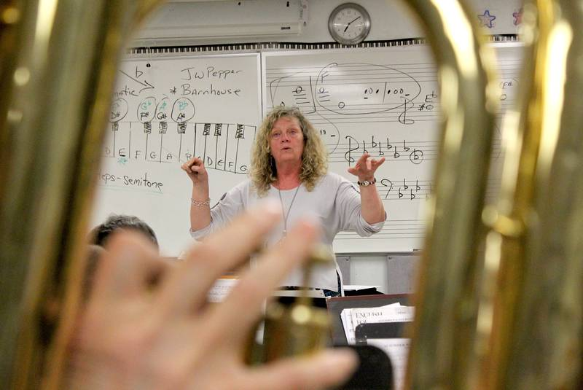
Conductor Laura Mercer is seen through musician Earle MacLean’s tuba as she leads the Second Wind Community Concert Band through rehearsal Thursday at Malcolm Munroe Memorial Middle School in Sydney River. The band was preparing for its upcoming “Here Comes Summer” show, which takes place Friday at Cape Breton University’s Boardmore Theatre. - Submitted

A quarter-century celebration
SYDNEY, N.S. — There’s nothing like music to celebrate a milestone anniversary and the Second Wind Community Concert Band will be remembering its 25th year with a brand-new piece of music commissioned from composer and arranger Scott Macmillan.
It’s a dream come true for conductor Laura Mercer who had previously spoken to Macmillan about the possibility of writing a special piece of music for the group’s anniversary.
“Scott and I talked about this for years that when Second Wind is grown up enough to be able to do his music that I hoped that we could commission him to do something,” said Mercer. “We played some of his music for our 20th anniversary but I thought by the 25th, let’s do it. The band was all for it. But it’s expensive, we’re not-for-profit so how do we raise funds for this — I didn’t know but the band agreed we would find some way to pay for it.”
Shortly after, Mercer saw an article in the Cape Breton Post looking for people to apply for the Ruth Goldbloom Performing Arts Award from the Charles and Mary MacLennan Foundation.
Mercer sent in a proposal and while it didn’t win the actual award, the award committee decided to give the group $3,000 anyway.
“Our committee was impressed with your submission relating to your 25th and the Scott Macmillan commission and we wanted to assist the project so we are pleased to enclose our cheque for $3,000 equivalent to the top prize in the Goldbloom award itself,” said the letter from the Charles and Mary MacLennan Foundation, which also noted that the actual 2018 award was given to Melina Markotjohn of New Waterford.
The money to Second Wind will be used to pay part of the $5,000 commissioning fee. The rest will be covered by public donations and money from the ensemble itself.
The actual work will be premiered in June 2019.
“Scott called me not that long ago to let me know that he is done. He’s got a title for it. It’s called “A Gift Of Time.” I haven’t seen it yet but … we’ll start working on it in September. It’s exciting — I’m really excited anyway.”
It’s just one of several activities that Mercer has planned for the group’s 25th year, including starting a band for those who have lost their playing ability but who wish to regain it. She also wants to upgrade the group’s website and social media presence to remain current with the times and to go into the high schools to encourage students to sign up for the group when they have left their high school bands behind. She’s even thinking about taking the group out on the road.
“We’ll go up to Baddeck and maybe play at the Alexander Graham Bell Museum or something and that will be our road trip,” she laughs.
In the meantime, the ensemble will end its 24th season with their annual June concert, “Here Comes Summer” on Friday at 7:30 p.m. at Cape Breton University’s Boardmore Theatre. They will be joined by the Cape Breton Comfort Choir, music therapist Jill Murphy, the Second Wind Saxes and 17-year-old concert pianist Evan Milligan.
Steve Sutherland will emcee the show and there will be a reception following the concert.
The concert is being held in support of the Hospice Palliative Care Society of Cape Breton County’s music therapy program. Tickets are $15 and are available at Mercers’ Service Centre, the Cape Breton Curiosity Shop, the Hospice Office or from any band member.
IF YOU GO
WHAT: “Here Comes Summer” concert by the Second Wind Community Concert Band.
WHERE: Cape Breton University’s Boardmore Theatre.
WHEN: Friday, June 8, 7:30 p.m.
TICKETS: Tickets are $15 and are available at Mercers’ Service Centre, the Cape Breton Curiosity Shop, the Hospice Office or from any band member.
news@cbpost.com

