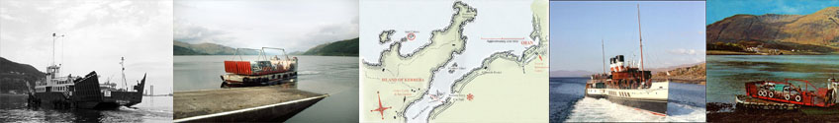

**AISEAG**

***Trusadh : Aiseag (The Ferryboat)*** gives unprecedented access to the creative musical journey of a major new commission for the 2014 Commonwealth Games. With the creative process beginning in March we get a view from the inside as we follow this visionary project as it grows from a mere concept to a fully-fledged international debut performance.

MacTV Scotland is producing an hour long film for BBC Alba to be released later this year; ***Trusadh: Aiseag (The Ferryboat)*** - a fascinating creative musical journey of people and place, that celebrates the place of the ferryboat in the Scottish rural west coast, but also resonates with the shared experience of rural communities in other parts of the Commonwealth, particularly Nova Scotia, Canada.

The stunning cliff top location of Sabhal Mòr Ostaig overlooking the Sound of Sleat on Skye provides the setting for the performance premiere, July 3rd, – guaranteeing an event that will be as visually impressive as it will be musically. The performance will then also take centre stage, as one of 20 UK wide flagship projects, celebrating international partnerships, with major concerts in both London July 5th and Glasgow August 2nd.

Highly respected musician, writer and composer, Mary Ann Kennedy has been inspired by the communities, culture, and connections on her own doorstep, to celebrate what is an international dynamic. She has hooked up with one of Canada’s most respected composers and an internationally recognised leading creative force, **Scott Macmillan**, and along with Watercolour Music’s resident producer, Nick Turner, and Gaelic poet Aonghas MacNeacail, they’ll create a unique new work which will place the Highlands and the Gaelic language and culture right at the heart of the Games’ celebrations.

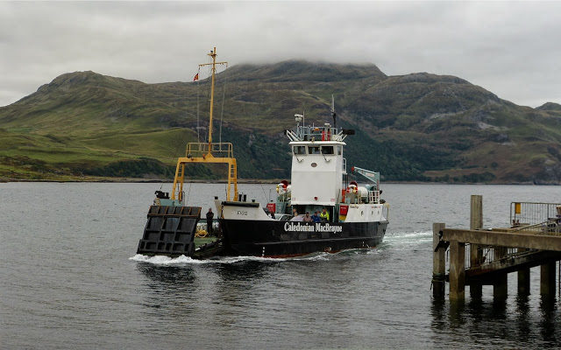 Ferryboats have long been a fascination for Mary Ann and have been a constant in her life – as a solution to geographical barriers, and offering a vital point of contact in scattered communities, transporting news and information as well as peoples and goods. The work will celebrate their importance in 2 rural Commonwealth communities – the Highlands and Islands of Scotland and the diaspora of Nova Scotia, Canada.

March sees the trans-Atlantic creative journey begin with Mary Ann and Scott on Skype regularly sharing ideas and writing, with musical ideas to-ing and fro-ing on the ether through file sharing. Much of the writing is inspired by the words of Aonghas Dubh’s evocative text, with a collaboration that will see a fusion of classical and traditional music, along with electronic, and innovative *biomusic*, with its roots in the very elements themselves – the tides, the depths, light arrays from the lighthouses etc. It also gives Scott an opportunity to work closely with the Gaelic language which has been a long held ambition for some time.

April sees workshops begin with the Inverness Gaelic choir under Mary Ann’s musical leadership as they gather in Kilmallie, and the layers grow week on week from there through to July, as we take ultimately take to the road and ferry and follow Mary Ann’s journey. It will culminate with the debut in July in Skye, with a performance only 2 days later on the Southbank embankment in London. The journey by sleeper from Fort William to London for a 30 strong choir and 20 musicians will be quite a logistical challenge in itself!